**CURRICULAM VITAE**

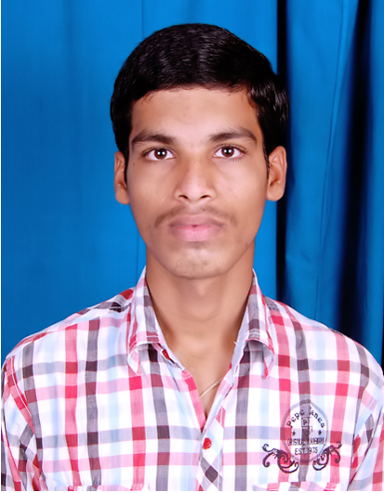

TAMARALA ABHISHEK ,

MAKHARAM PURAM VILLAGE,

KANCHILI MANDAL,

SRIKAKULAM DIST,

ANDHRA PRADESH,

PIN: 532290. Email Id:abhishektamarala@gmail.com

Mobile : +91 9908507796

**______________________________________**

**CARREER OBJECTIVE:**

I seek to join a dynamic, competitive and performing organization, which provides me with ample opportunities to learn, improve, grow and revitalize myself steadily.

**QUALIFICATIONS:**

| **S.No** | | **Degree** | **School/College/University** | **Year of Passing** | **Percentage/Division** |
| --- | --- | --- | --- | --- | --- |
| 1 | S.S.C | | MAHARSHI VIDYA NIKETAN | 2009 | 65% |
| 2 | INTER | | VISHAKHA JUNIOR COLLEGE  VISHAKAPATNAM | 2011 | 62.6% |
| 3 | B.S.C | | SAMSKARA BHARATI DEGREE COLLEGE | 2017 | 65% |

**Computer skills:**

* MS-OFFICE,DCA,DTP,TALLY,PGDCA,WEB-DESIGNING

**STRENGTHS:**

* Hard working nature
* Easy to learn new things
* Good communication skills

**HOBBIES:**

* Reading books
* Listening music
* Playing cricket

**Working experience :**

**COMPANY NAME DEPARTMENT WORKING PERIOD**

**Shriji polymers, HYDERABAD QA (NOV)2020 - (MAY)2022**

**PERSONAL PROFILE:**

Name : TAMARALA ABHISHEK

Fathers Name : S/O RAMARAO,

Date of Birth : 15-05-1994

Sex : MALE

Door No : 2-272

Marital Status : Unmarried

Religion : HINDU

Nationality : INDIAN

Languages Known : TELUGU,ENGLISH,HINDI

**DECLARATION:**

I hereby declare that the above-furnished information is true as for my Knowledge and belief.

**Place:**

**Signature**

**Date:**

**(**TAMARALA ABHISHEK**)**